

FortnaPlus Control
PackLift Module
Document Revision: 1.1
Date: 20-Jul-2022

Revision | Date | Author | Revision Summary
1.0 | 23-Apr-2013 | B C Conklin | Update the format
1.1 | 20-Jul-2022 | T R Kremser | Update and general refresh

Table of Contents
Glossary of Terms 4
1. The Pack Lift Module 5
2. Table PackLiftConfig 5
3. Table PackLiftControl 7
4. Table PackLiftStates 9
5. Pack Lift Logic 11
6. Source Code Files 12

Confidential/Proprietary Statement
This document contains trade secrets and information that is considered confidential and proprietary to Fortna, Inc. It may not be duplicated, used, or disclosed outside the original recipient organization, and it may not be duplicated, in whole or in part, for any purpose other than to evaluate this document. Fortna Material Handling reserves the right to modify this document as necessary to reflect any terms and conditions negotiated and included as part of a subsequent contract or purchase order.

Glossary of Terms
AC – Automation Controller
FPC – FortnaPlus Control
UPS – Uninterruptible Power Supply

The Pack Lift Module
The Pack Lift module is used to control specialized hardware for presenting containers to operations personnel so they can perform manual operations on them while working at a comfortable height.
The module manages the photoeyes, proximity sensors and pushbuttons to move the containers in the desired way and detect errors when the sequence is violated.
NOTE: The Pack Lift module must be activated in table Batches using File_Name = Pack Lift, HowOften = 1, Type = Count, Process = CTRL, InternalProcCtrl = PackLift, and Machine = <Your AC> or AllMachines = Y.
The Pack Lift module is configured using three tables. These tables can be found in the Pack Lift Menu: Configuration Menu | Pack Lift Utilities
Table PackLiftConfig defines an entry for each pack lift device.
Table PackLiftControl is maintained by the software. Each pack lift will have an entry on the row that corresponds with the entry in table PackLiftConfig. The software uses the fields in PackLiftControl to keep track of the current state and timing information for each pack lift. The Name from PackLiftConfig is copied to the corresponding row in PackLiftControl.
Table PackLiftStates defines the individual steps (states) that a container must follow as it moves through the pack lift. The table contents will be filled in when the module first starts. Name defines each state. The pack lift must stay in each state for at least MinTimeMSec milliseconds, even if the conditions are satisfied for it to move to the next state. When leaving a state after the conditions are satisfied, it is considered an error if the pack lift does not move on to the next state within MaxTimeMSec milliseconds – the lift will enter the Fault state and stay there until manually reset. When the table is populated, default values are set for these times, but they can be altered as appropriate.

Table PackLiftConfig
Table PackLiftConfig (Configuration Menu | Pack Lift Utilities | Pack Lift Config) is used to define each pack lift.
PackLiftConfig Table
Field | Type | Description
Name | String | Enter a unique name for this pack lift.
pStatus | String | Set by the software to show the state of this pack lift. This is a copy of the similarly named field in table PackLiftControl.
LogLevel | Int | Set the detail level for messages written to the CTRL log. Search for “PackLift” in the log files. Each message refers to the row number in this table.  0 – Error messages only.  1 – State machine state change information.  2 – IO state change information.
ResetYN | Y/N | Not used.
ZoneLatchIO | PopUp | Choose the input that indicates it is OK for this pack lift to run – from the Start/Stop zone. If this input goes OFF, the lift will stop and enter the ZoneDisabled state.
LaneEnableSW | PopUp | Choose the input from the mechanical switch that controls the state of this pack lift lane.
LaneClearTM | PopUp | Choose the clear timer for the full photoeye on the gravity section to which this pack lift lane discharges.
AccumProductPE | PopUp | Choose the photoeye input from the end of the accumulation section just prior to this pack lift.
LiftEntryPE | PopUp | Choose the photoeye input closest to the entry point of this pack lift. A fully loaded tote must be clear of this photoeye.
LiftLoadedPE | PopUp | Choose the photoeye input which a tote will block when fully loaded.
LiftUpPROX | PopUp | Choose the proximity sensor input that indicates the pack lift is fully raised.
LiftDownPROX | PopUp | Choose the proximity sensor input that indicates the pack lift is fully lowered.
AccumReleaseSSV | PopUp | Choose the output that controls the release solenoid for the accumulation conveyor.
LiftMotorIO | PopUp | Choose the output that starts the lift motor. See SetDirectionMSec.
LiftDirectionIO | PopUp | Choose the output that sets the direction for LiftMotorIO to run. This output will be Fired to unload and Unfired to load the pack lift. See SetDirectionMSec.
SetDirectionMSec | Int | Set a time, in milliseconds. LiftDirectionIO will be Fired for this much time before LiftMotorIO is Fired.
LiftMoveUpSSV | PopUp | Choose the output that tells the pack lift to move in the upward direction. See UpDownPulseMSec.
LiftMoveDownSSV | PopUp | Choose the output that tells the pack lift to move in the downward direction. See UpDownPulseMSec.
UpDownPulseMSec | Int | Set a duration, in milliseconds, for the pulse for LiftMoveUpSSV and LiftMoveDownSSV.
ErrorIO | PopUp | Optionally choose a memory bit here to trigger an error in the Errors table when a fault condition is detected.

Table PackLiftControl
Table PackLiftControl (Configuration Menu | Pack Lift Utilities | Pack Lift Control) is filled in by the software with rows matching those in PackLiftConfig. It contains information about the current state of each pack lift.
PackLiftControl Table
Field | Type | Description
Name | String | Set by the software to the same name entered in the corresponding row of table PackLiftConfig.
pState | PopUp | Set by the software to the current state of the pack lift, as defined in table PackLiftStates.
pStatus | String | Status messages set by the software:  Program Restart – Everything is reset to an appropriate state. Next state: ZoneDisabled.  ZoneLatchIO Turned Off – The zone has been disabled. Next state: ZoneDisabled.  ZoneLatchIO Turned On – The zone has been enabled. Next state: ResetLift  Max Time Exceeded – The inputs for the new state took longer than PackLiftStates_MaxTimeMSec to come on. Next state: Fault.  LaneEnableSW Turned Off – The switch was manually set OFF. Next state: LaneDisabled.  LaneEnableSW Turned On – The switch was manually set ON. Next state: ResetLift.  Lift Appears Empty – This will occur when recovering from the ResetLift state. LiftLoadedPE and LiftEntryPE. Next state: MoveUp.  Lift is Down – This will occur when recovering the ResetLift state. LiftDownPE is ON. Next state: Unloading.  Lift is Up – This will occur when recovering the ResetLift state. LiftUpPROX is ON. Next state: HoldNext.  Lift Properly Loaded – This will occur when recovering the ResetLift state. LiftLoadedPE is ON, LiftEntryPE is OFF. Next state: MoveDown.  LiftUpPROX Turned On – This will occur from the MoveUp state. LiftUpPROX is ON. Next state: ArriveUp.  AccumProductPE is On – This will occur from the ArriveUp state. AccumProductPE is ON. Next state: Loading.  AccumProductPE Turned Off – This will occur from the Loading state. AccumProductPE is OFF. Next state: HoldNext.  Lift Appears Full – This will occur from the HoldNext state. LIftLoadedPE is ON, LiftEntryPE is OFF. Next state: FinishLoading.  Lane is Clear – This will occur from the FinishLoading state. LaneClearTM is done. Next state: MoveDown.  LiftDownPROX Turned On – This will occur from the MoveDown state. LiftDownPROX is ON. Next state: ArriveDown.  Lane is Clear – This will occur from the ArriveDown state. LaneClearTM is done. Next state: Unloading.  Lift Appears Empty – This will occur from the Unloading state. LiftLoadedPE is OFF, LiftEmptyPE is OFF. Next state: MoveUp.  For the following “Fault” messages, the named thing changed state unexpectedly. The next state is Fault for all of these:  Fault:Up Prox Turned Off  Fault:Up Prox Turned On  Fault:Down Prox Turned Off  Fault:Down Prox Turned On  Fault:Product PE Turned Off  Fault:Product PE Turned On  Fault:Entry PE Turned Off  Fault:Entry PE Turned On  Fault:Loaded PE Turned Off  Fault:Loaded PE Turned On
pStateStartSec | Int | Set by the software to the whole second portion of the time from the system clock when a new state is entered.
pStateStartNSec | Int | Set by the software to the nanosecond portion of the time from the system clock when a new state is entered.
pUpDownSec | Int | Set by the software to the whole second portion of the time from the system clock when an up / down move is started.
pUpDownNSec | Int | Set by the software to the nanosecond portion of the time from the system clock when an up / down move is started.
pDirectionSec | Int | Set by the software to the whole second portion of the time from the system clock when a load / unload move is started.
pDirectionNSec | Int | Set by the software to the nanosecond portion of the time from the system clock when a load / unload move is started.
pUpDownSubState | Int | Set by the software to indicate the current state of the up / down SSVs.
pLoadUnloadSubState | Int | Set by the software to indicate the current direction of the load motors.

Table PackLiftStates
Table PackLiftStates (Configuration Menu | Pack Lift Utilities | Pack Lift States) is automatically populated by the software with the states used by the state engine. Timers define the minimum time the state engine will stay in each state, even after the required inputs for the state are satisfied, and the maximum time allowed for the required inputs to appear after the next state is set.

PackLiftStates Table
Field | Type | Description
Name | String | Populated by the software. The name of each state in the state machine.
MinTimeMSec | Int | The minimum time, in milliseconds, that the state machine must spend in the given state once the required conditions for entering that state have occurred. Even if the conditions have been met for the next state, the state machine will remain in this state until this timer has expired.
MaxTimeMSec | Int | The maximum time, in milliseconds, that is allowed when conditions have been met to move into a new state (including the MinTimeMSec) before a fault is declared. This will occur if the conditions for the new state have not been met when the timer expires.

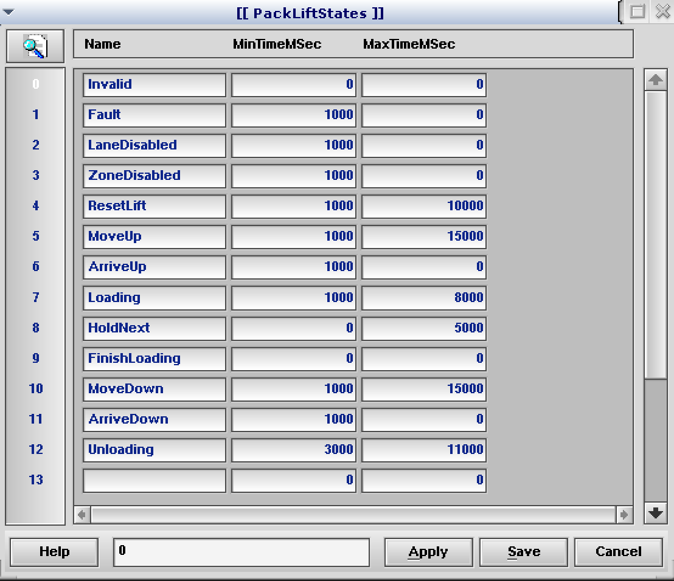

Pack Lift Logic
The following is a state diagram for the Pack Lift Module.

Source Code Files
The Pack Lift module is defined in these source code files:
- PackLift.c – Contains the code that controls Pack Lifts.
- PackLift.h – Contains the hook function declarations.
The table definitions are found in fortna.mnu.

